SUBJECT: Sample Questions and Statements to Support PCOC | DATE: 10/28/2021
TARGET AUDIENCE: MyOptions Advisor | REFERENCE NUMBER: TBD
TYPE: ☐ NEW ☒ REVISIONS: | REVISION DATE:
PURPOSE: Sample opening statements and questions to support MyOptions Advisor conversations.
CHANGES SINCE LAST REVISION:
- 1/11/21 revised content throughout based on input from the MyOptions Advisors.

DOCUMENTS/ASSOCIATED RESOURCES:

ATTACHMENTS: N/A

This document includes example questions and opening statements to support the entire PCOC process. The entire PCOC process includes 5 steps; however, the consumer may not require or chose to participate in every step. The consumer should have complete control over this process.

- Welcome
Your greeting and introduction to the consumer provides an opportunity to make a positive first impression and affirm that the person contacted the right place. This will set the tone for the conversation. Sharing your role early in the conversation can help clarify expectations. Each conversation is different, and each consumer is unique. Explaining your role may help if the person is hesitant or concerned about another person.

Sample Opening Statements or Questions
MyOptions Advisor Calls the Consumer Directly
- Incomplete Application: Hello <insert consumer name>, my name is <your name> and I will be your MyOptions Advisor. We received your application for home care and we are calling, while your application is being processed, to gather more information about you and your goals for the programs. Is now a good time to talk?
- Referral 1: Hello <insert consumer name>, I received your referral and I am calling to gather more information about you and your goals for the programs. Is now a good time to talk?
- Referral 2: Hello <insert consumer name>, I received your contact information from <insert referral name> regarding your interest to learn more about your options for care at home or in the community [or assisted living, etc.]. Is now a good time to talk?
- Voice Mail: Hello <insert consumer name>, my name is <your name> and I am following up on your call placed on ______________ regarding your options for care at home or in the community [or assisted living, etc.]. Please give me a call back if you are interested in finding out more about services or discussing your options. You can reach me at _________________.
Consumer is Calling the MyOptions Advisor Directly
- What brought you here today? OR Why did you decide to call us?
- What can I help you with today?
- If it is okay with you, I’d like to ask you some questions to help me better understand your situation.
Urgency
- How quickly do you need help?
- Do you need immediate health care assistance?
Clarify Role
- If it's okay I’d like to share a little bit about my role and how this process works. We have lots of information about services at home or in the community. I’ll need to learn from you what you are looking for and what makes sense for you. We’ll sort through these options together; however, any decisions about next steps are yours. How does this sound to you?
Empower (consumer is in charge)
- It sounds like placing this call was difficult for you. I am glad you called.
- The goal of Person Centered Options Counseling (PCOC) is not to steer someone towards a particular goal, rather our goal is to inform you about your options. We are just having a conversation to inform you about your options. Any decisions to be made are yours to make.
Race Question
- Which of the following best describes you? [Review race options]
- WHY we collect: The State uses race information to evaluate this program and to ensure that our services equitably serve the needs of all racial groups.
Confidentiality
- Everything we discuss is private and will NOT affect your ability to get the types of services you choose.

- Intake and Screening
Intake and Screening (I&S) is a preliminary assessment of the need for LTSS and focuses on health status, functional limitations, financing associated with eligibility for LTSS services and programs.

The responses to I&S questions focus on the following personal areas: health status, finances, living arrangements, and functional limitations.

Sample Opening Statements or Questions
Consumer Status
- I’d like to ask a few background questions and talk to you more about your situation and health. You may have told us about some of this before, but we want to make sure we have the most up to date information.
- Do you have any health concerns that you think I should know about?
- It sounds like you need help right away. I will try to connect you with _______________. This is the contact information for what you need________________________ if you do not get a person. Please call back and leave a message if you do not get connected.
- Tell me about services or other help you might have tried or are currently receiving.

Health Insurance and Finances
- To help me get a sense of what types of services might be best for you, I’d like to talk with you about your income and resources.
- If you don’t know exact amounts, don’t worry. Your answers won’t be used to determine your eligibility for Medicaid or other government programs or affect any benefits you are getting now.
Living Arrangement
- Where are you living right now?
- (If unclear:) Do you own the house? (If an apartment:) Is this elderly/disabled housing?
- How well is the place that you are living working out for you? Are there things you would change about it?
- If living with some else, is that person a caregiver?
- Are there people who help you on a regular basis?
- (If talking to a caretaker) Are there people other than yourself who help ___ on a regular basis?
- How are you able to get around? Do you drive? Do you need to get a ride from someone?
Functional Abilities
- I’d like to talk to you about what activities you have done recently. Do you do these things by yourself or if you receive help or would like help from someone else on the days you do them.
- Now let’s talk about what areas that you may need help in. I will go through the list and you can answer yes or no if you generally need assistance in that activity. If you choose to receive services, someone will contact you to discuss these activities in greater detail, so just a simple yes or no is sufficient.

PCOC
PCOC is an interactive decision-support process that helps people assess and understand their LTSS needs, goals, and preferences. This approach of supporting consumers is directed by the individual and may include caregivers, natural supports, or those who are legally authorized to represent the individual.

Decision-support takes place when programs or services are explored that may fit the individual’s situation. Evaluation of the pros and cons of each service is discussed; and the values and preferences are applied to the choices. Decision-support leads to an understanding of the “why" - why something is important to the person.

PCOC may not be appropriate for all consumers. Listen to cues and talk with the consumer about the PCOC process to determine whether it is an appropriate next step.

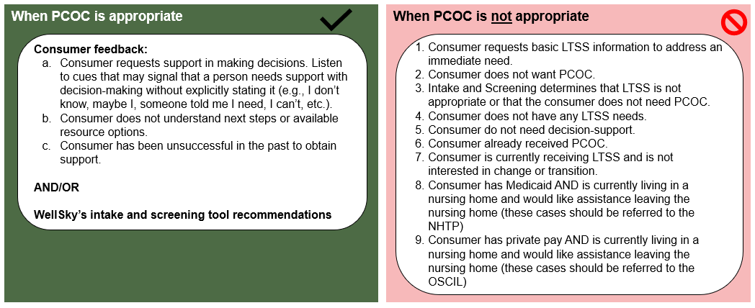

Sample Opening Statements or Questions
Introducing the Concept of PCOC
- I’m here to listen and help you make decisions that are right for you based on what you tell me. This information will be used to prepare a resource that you can use when you discuss your goals throughout the LTSS process. It will be your resource and can change.
- You have given me important information to help create a resource for next steps. Now, let’s shift to gathering a bit more to complete your action plan. Let’s talk about what you think matters most in your current situation.
- Is there anyone else important to you that you would like to be in this part of our talk? If yes – Can they come to the phone now, can we call them now, or would you like me to call you back?
Consumer background/preferences
- Tell me more about yourself and what’s happening now – e.g., reason for inquiry about LTSS?
- What’s your biggest goal? What is needed to help you achieve it?
- Do you need help? Does someone help you now?
- Who are the people that you count on for support when you need it?
- Who are the people you are close to? in your family? at work? neighbors and friends? These will be people you can talk to along the way, people who can provide support to you when you need it.
- Has the COVID-19 virus changed how you live?
- What makes you the happiest right now?
- What would you say is the one thing/person is the most important to you?
- What are things that you used to do that you are no longer able to do?
- What kind of job did you used to do when you were younger or before you were ill? Did you enjoy it?
Living Arrangement
- What is your ideal living situation?
- If ‘living situation’ is confusing, especially after interpreted, try: If you could imagine an ideal way to live, what would it be like? How would you change your current living situation?
- Does your current living situation help you reach your goals (need for LTSS - however described)?
- Does someone you live with (caregiver name if known) help you day-to-day? (Ask them the name/relationship if they say yes)
- Who takes care of the inside and outside of your home?
- Where do you feel most safe? Are there times when you don’t feel safe where you live? If yes, when/why
Wants (now and in the future)
- What do you want now and in the future related to … [education, family, recreation, community involvement, work/volunteer activities]?
- What do you want in life? Remember, there are no right or wrong answers!
- The most important thing in this decision is ____________. Did I get that right?
- Is working or volunteering a goal?
- Are family and friends able to help?
- Tell me about the help your ____________ (family and friends) provide.
- What do you like the most or miss the most about ____________ (working and volunteering)?
- Where do you see yourself in the next 3-5 years? Where will you be living?
- What kinds of support will you need?

Strengths
- What do you do well?
- What are some great things about you?
- Is there something you think you’re really great at or better than anyone else at doing?
- These are important things to think about when you are figuring out the kinds of services and supports you need and want.
- What are some things you're good at? proud of?

- Action Plan/Summary
The PCOC Action Plan helps the consumer move from identifying the resources that best fit their wants to specifying next steps to access those resources and achieve their long-term support goals. The PCOC Action Plan is meant to guide the PCOC process and to ensure that consumers receive a consistent and similar experience across MyOptions Advisors. The consumer should have complete control over this process and make choices about goals and activities that match their interests and desires and address what is important TO them, what is important FOR them, and the best way to SUPPORT them.
Align your PCOC Action Plan to the SMART concept
- S is for specific. Things should be stated clearly and simply.
- M is for measurable. This means everyone can tell when something is done (e.g., who, what, by when, etc.).
- A is for assigned. It should be clear who specifically is responsible for getting each action step done. Don’t assign steps to “the team” or “the family.” List out who specifically is responsible.
- R is for relevant. All aspects of the approach should be relevant to the person and make sense from their perspective.
- T is for time-bound. This means a specific date or timeline is listed for each action step. This helps make sure that the person and MyOptions Advisor have a similar understanding of how long something should take.
During the Action Plan development process, MyOptions Advisor will discuss and document:
- A high-level summary of the person
- Consumer goals and preferences
- Action steps to achieve identified goals
- Potential funding source and resources to support goals
The PCOC Action plan is sent to the consumer via email or mail after the initial PCOC session and after the final PCOC session.

Sample Opening Statements or Questions
Goals
- Now it’s time to start thinking about what things should be written into your Action Plan. The best way to do this is to think about what will help you do the things you like to do and need to do.
- This _____________ (goal) is important to you. Did I get that right?
- The most important thing in this decision is ________________. Did I get that right?
Action Steps – who, what, when
- What do you think your next step will be?
- How long do you think it will take to make this happen?
- Who might help you with this?
- Is there anything I can do that would be helpful?
- How can I assist you to make what you need, __________________, happen?
- Is there anything (maybe there isn’t) that might get in the way of this happening?
Service Options
- Sometimes information about services is confusing. If I say something that isn’t clear, then please let me know.
- If it’s okay with you, Let’s talk about a couple of options that might be helpful. How does that sound to you?
- Earlier you said that one of things most important to you is ________________. And another is __________________. These are some of the options that can help you meet this/these goals.
- Do any of these sound right for you?
- What do you like most about this choice and what most concerns you?
- Tell me why this is the best fit for you?
Decide Next Contact – date, time (if appropriate)
- Is it okay with you if I call you within three weeks? (PCOC policy = 15 business days)

- Follow-up
The final step in the PCOC service delivery process is follow-up. Follow-up provides an opportunity to check back and learn how the individual is doing, what happened or didn’t happen, and if anything has changed. Follow-up services also help to address the changing needs and preferences of consumers and further refine the decision-making process. During follow-up, MyOptions Advisors should verify services by:
- Determining whether the referrals were implemented effectively
- Determining the extent to which the consumer’s goals have been met by contacting the consumer according to the agreed upon timeframe
- Revising action plans as needed to meet consumer needs, preferences, and values
- Identifying additional services (e.g., family meeting, new referrals) identified through follow-up to assist consumers to receive needed and preferred services; and ……
Sample Opening Statements or Questions
Progress Check
- Hello, this is ________ from the _______. Did I catch you at a good time? Just checking in to see how it’s going and to ask if you need any help or if things have changed. (Follow where it leads)
- Do you have any updates since the last time we’ve talked?
- Was the information I sent you helpful? What did you think about it?
- Thinking back to our conversations, tell me any thoughts you’ve had since we talked.
Close-Out and Survey
- Is there anything else I can help you with? Do you want to discuss any changes or other options?
- If there is nothing else, thank you and I hope you will take the time to complete an online survey.
  - Person-Centered Options Counseling is a new program, and we are looking for ways to improve it.
  - The online survey link and QR code will be included in a separate letter that I send to you after this call. You can also call the phone number on the letter to complete the survey over the phone.

