Executive Office of Health and Human Services

RI DXC Provider Electronic Solutions Installation Instructions
Provider Electronic Solutions (PES) may be installed on your local hard disk drive or on a network system. Providers may also choose between a workstation (used when installing to individual PC in a network installation) and typical installation (for single application). PES may be installed on numerous PCs. In the event the program and files are damaged or deleted, you can download the software from the EOHHS website to reinstall PES: (http://www.eohhs.ri.gov/ProvidersPartners/BillingampClaims/ProviderElectronicSolutionsPESSoftware.aspx).
The following requirements are needed for PES:
- Windows 98/2000/XP/Windows 7
- MS Internet Explorer
- 64 Megabytes RAM,
- 800x600 Resolution
- 100 MB Hard Drive Space available
- 28.8 Modem

The software is not compatible with Terminal Servers.

Note: Please disable all anti-virus software before proceeding with the installation or upgrade of the PES software. Your Firewall can also prevent the software from downloading.

When you install PES you must have administrator privileges in order to upload the files.

Establishing Your Password

The password for successful submissions is accessed under TOOLS, OPTIONS in the field named “web password”. This is the password that must be synched to the password used to access the Healthcare Portal. To enroll on the Healthcare Portal:

- Navigate to: https://www.riproviderportal.org
- Click the link under: Would you like to enroll as a Trading Partner?
- Complete the enrollment and registration. Additional instructions can be found on the Healthcare Portal page: http://www.eohhs.ri.gov/ProvidersPartners/HealthcarePortal.aspx

Download Installation for a Single Workstation
Please note:

If you install the application as a Typical installation on more than one PC, you will not be able to share data between the PCs.

You may obtain the current HIPAA compliant version of PES via the EOHHS Web Site. Go to https://www.eohhs.ri.gov, hover over Providers and Partners then select Billing and Claims, then select Provider Electronic Solutions (PES) Software, then choose the appropriate link under the Full Installation:
Once the software has downloaded to your computer navigate to the download folder and double click on the 2.13 executable. This will begin the self-extraction and installation process to your C Drive.

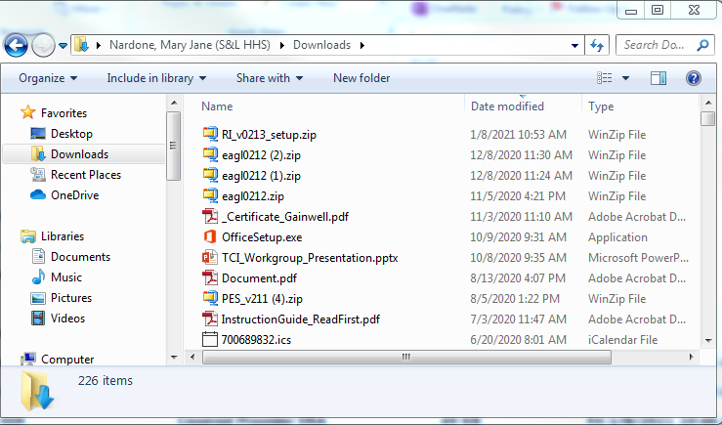

The process below will begin once you have launched the wizard. Follow the steps below:

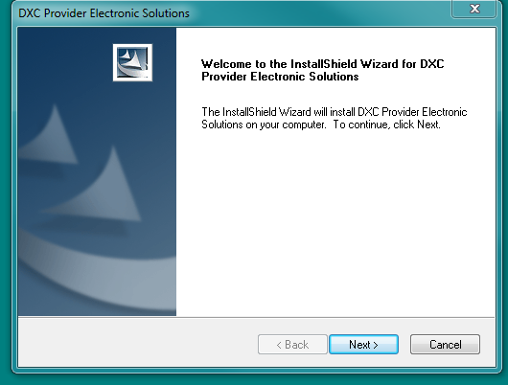

Click on next

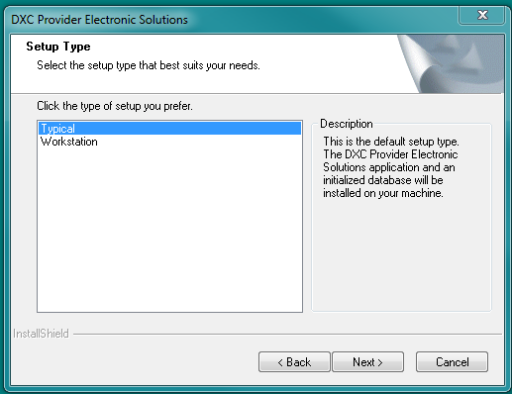

Select Typical for the single workstation installation and click next

Select next below for the default setup to the C Drive

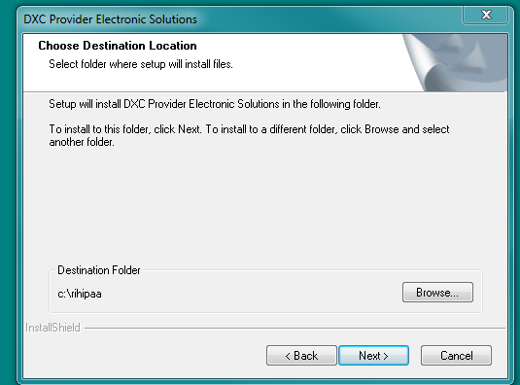

Select Okay in the next screen and the Install Wizard Window Complete will appear.
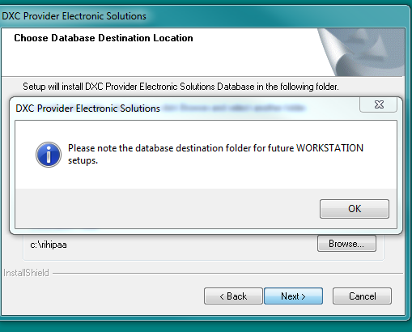

Click on FINISH. The software has been installed.
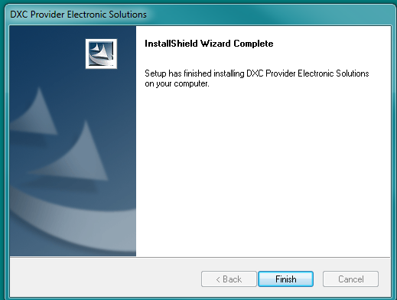
Proceed to the following pages for set-up instructions.

Network Installation

Several users may access Provider Electronic Solutions at the same time. To install the application for use by several users, you will need to perform a network installation. The following instructions will install the shared database on a network.
Follow the instructions above for a single installation but save the software to your network. When asked for the type of installation, select Typical. Select the location on your PC or accept the default directory for the application. Click Next. For the location of the database, select the directory on the network where you want the database to be located. ***The software application and the database must reside on the same drive. *** This will allow users from multiple PCs to access the application data. Click Ok to begin the set up and when the Install Wizard Shield Screen appears click complete.
Repeat this process on the individual PC’s of the users. When prompted for the type of installation, select Workstation instead of Typical. When prompted, enter the location on the network where the database was installed.
Proceed to the Set-Up instructions below.

Set-Up Instructions

Accessing the Program
- Double click on icon for RI Provider Electronic Solutions
- Double click on the DXC icon
- You will prompted to enter a password type in “dxc-pes”
- The message password expired will appear on your screen
- Click OK
- Type in dxc-pes in the Old Password Field
- Type in your new password in New password and re-enter that same information in the Re-Key New Password **must be 6 to 8 characters
- Select a Security question and key the answer twice.
- The main menu will appear with a message asking the user if they wish to set up their OPTIONS at this time, click ok

IMPORTANT MUST COMPLETE
Setting Up your billing OPTIONS will allow access for directly billing your claims to DXC as well as accessing the RI Provider Healthcare portal. Failure to complete this step will prevent you for submitting your claims. Complete the Batch Tab under Options by following the instructions below.

Batch Tab

- Enter your trading partner ID assigned by DXC in the Trading Partner ID Field
- Re-enter your trading partner ID for the Web Logon Field
- Enter your new password (the password that you created on the EOHHS Healthcare Portal for your trading partner ID, See page 1 for steps on how to do this.)
- Select the appropriate entity type qualifier
- Enter Last and First or Organization name as appropriate
- Type in Contact Name
- Select method of contact (ie: TE – telephone, FX – fax). If entering phone number enter the appropriate number including area code – no dashes

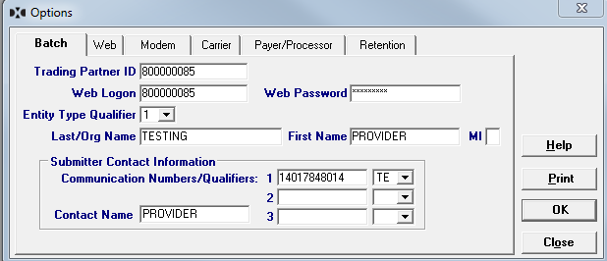

Web Tab
- Verify that Microsoft Internet Explorer Pre-config settings is checked to utilize your internet service provider
- The Environment Indicator defaults to P
- The other fields are not required.

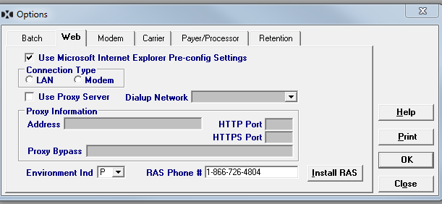

Modem Tab

- This defaults to the choices in the example, no changes are necessary
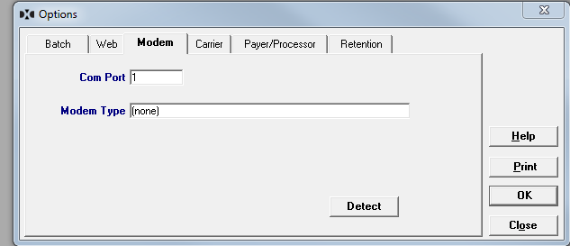

Carrier Tab

- Select Batch Web in the drop down of the Carrier ID box
- Select Batch Web under Transaction Type at the very bottom of the box
- Select Carrier ID box again – which is now empty and select Batch Web again
- The last process will auto populate the bottom box
- Confirm that P has been selected for Production/Test Indicator

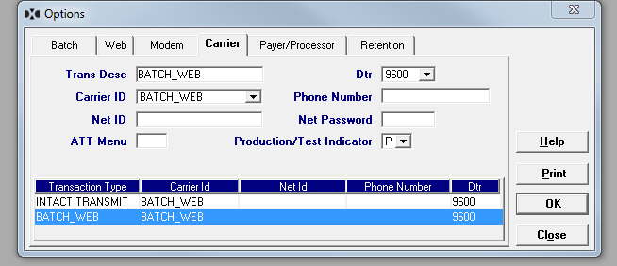

Retention Tab
- The Archive Days is preset at 30 days, this may be changed to anything between 1 and 999 to suit your needs
- Change max batch, verify, log reports, to which ever suits your needs recommended 60-90
- Set expiration days for password re-set, max days is 99. (this will determine how often you are prompted to change your password to get into the software)
- Click Ok



