Sandata Mobile Connect App
  - TRANSITION GUIDE

Where do I find the new app?
The new and improved app will be listed in the Apple Store and Google Play as Sandata Mobile Connect, mid-July. The original app will be renamed to Sandata Mobile. Look for the purple icon for Sandata Mobile Connect.

Sandata Mobile Connect App (opening July 2023) | Sandata Mobile App (live until July 2024)
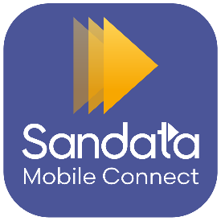 | 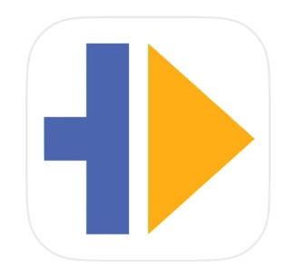

How do I download the app?

1. Visit the App Store or Google Play store, depending on your mobile device.
2. Type “Sandata Mobile Connect” in the store’s search bar.
3. Select the listing with the purple Sandata Mobile Connect app.
4. You will be taken to the app’s page. Click the “install” or “get” button. You may need to enter your device password to complete the download.
5. Look for the app on your home screen.
6. Tap the icon to open the app and start using it.

What do I need to log in to the app?
To log in to the new Sandata Mobile Connect app, you will need to enter a username and password of your choice.

Username: Please use an email address you already use with your agency. If you have accounts with multiple agencies, you only need to select one of those emails. With our new simplified sign-on process, you’ll select your agency after sign-on.

Password: When signing-on for the first time, you will be asked to create your own password.

With the new app, you will use the same username and password for all your agency visits. You will not need to log-on separately for visits with different agencies. You will only need to remember one username and password.

What are the benefits of the new app?
The new Sandata Mobile Connect app focuses on the customer experience. Caregivers will have better functionality and guidance within the app to complete record keeping in real time, allowing them to spend less time in the app and more time with their clients.

Can I continue to use the original Sandata Mobile app?
You will still be able to log in to the original app, Sandata Mobile. If you log in to the new Sandata Mobile Connect app, your username and password will be updated for the existing Sandata Mobile app as well.

Can I use both apps at the same time?
Yes. You can use both apps at the same time. However, if you begin a visit in one app and end it in another, you will need to reenter any tasks completed during that visit.

Will any existing features go away with the launch of the Sandata Mobile Connect app?
No. At this time there are no features that will go away. There may be slight differences in how things look or how they might be referred to, but the core functions will remain the same.

Is there any training available for the new app?
Yes. Training will be available on Sandata On-Demand for all new features pre-launch. Additional training documentation for existing features will be updated with the new look of the app as soon as possible.

What happens if I forget my password to the new app?
Password reset has been made easier with the new app! Now, instead of reaching out to an administrator, you’ll be able to request a password reset prompt to be sent to your email and can reset your password yourself.

